

Integration Design Document



October 14th, 2014

Prepared by

Matt McKinley, Technical Architect

Sharon Lorenz, Engagement Manager

Michael Turck, Solution Architect

Rich Resnick, Executive Sponsor

**Disclosure**

This document is Silverline Proprietary and Confidential information. Neither this document nor its content may be revealed or disclosed to unauthorized persons or sent outside the institution listed on the cover page of this document without prior permission from Silverline.

**Contents**

1 Document Overview 5

2 Overview 5

2.1 Angelo Gordon Salesforce Data Model 5

2.2 Functional Requirements Overview 6

3 Website (ITG) 6

3.1 Fund Info Export 6

3.1.1 XML Layout / Elements 6

3.1.2 XML Attributes 7

3.1.3 Open Questions: 8

3.2 Contact Level Services Export 8

3.2.1 XML Layout / Elements 8

3.2.2 XML Attributes 8

3.2.3 Open Questions: 9

3.3 Service Export 10

3.3.1 XML Layout / Elements 11

3.3.2 XML Attributes 11

3.3.3 Open Questions: 14

3.4 Valuation Export 14

3.4.1 XML Layout / Elements 14

3.4.2 XML Attributes 14

3.4.3 Open Questions: 15

4 Third Party Administrator (SEI) 16

4.1 Investor 17

4.2 Class Series 20

4.3 Relationships 20

4.4 Related Contacts 21

4.5 Wire Instructions 22

4.6 Documentation Permissions 23

5 Data Warehouse (Valuations) 27

6 Investran 27

Figures

Figure 1: Data Model 5

# Document Overview

The Integration Design Document (IDD) is the primary deliverable of the Integration portion of the design phase of the Silverline Implementation Methodology. In addition to detailing the prioritized functional and technical requirements for the Angelo Gordon’s integration, the IDD also includes the recommended system design based on the functional requirements (i.e. the project scope) that were defined in the discovery phase. In this document, interfaces, filter logic and workflow are detailed to an actionable level and signed off by the client prior to the start of the development effort.

# Overview

## Angelo Gordon Salesforce Data Model

The below Entity Relationship Diagram shows the SFDC data model in Angelo Gordon’s SFDC implementation. This data model encompasses all of the custom objects and relevant standard objects in AG’s Salesforce Org. A subset of this data model is shown in following sections as it relates to individual Integration flows.

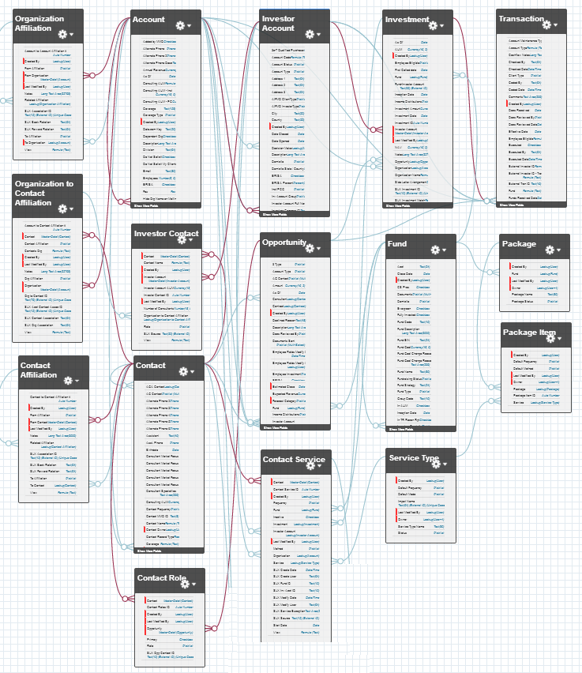

Figure : Data Model

## Functional Requirements Overview

# Website (ITG)

Angelo Gordon’s client-facing website provides a portal for Investor Contacts to view documentation about their Investments. As an organic extension of the data and user interface of Salesforce, Investor Service permissions and preferences will be managed in Salesforce. Salesforce will generate XML files so that the Investor Service Preferences managed in Salesforce are reflected in the portal itself. The synchronization will be 1 way from Salesforce to ITG, and will occur on a batched basis. The data will be in the format provided by the website implementation partner, ITG and will utilize the standard XML interface.

For each type, the process is the same:

**At the schedule for the Batch: (AG-ITG):**

* AG will generate each XML file using custom code and a batch process and will save the files to the Salesforce Documents repository
* A set of Informatica tasks will save them into a specified folder
* AG’s uploader process will listen for any new files added to that directory and move the files to the ITG FTP site
* ITG receives the files from their FTP site and processes them

## Fund Info Export

The Fund Info Export file is an XML file that will contain Funds and related attributes that are important to be included on the website.

The XML file will be broken up by Metadata and Data elements, with the data elements containing Fund and Fund Attribute elements only, which will all derive from the single Fund__c Object. All the Funds with a Status = “Active” and ITG_ONWEBSITE__c = True will be included in the Export.

A custom setting will be added that will contain the list of fields that should be included as possible Fund Attributes, and for each Attribute listed, only the Fund Attributes that are NOT NULL will be included for each Fund within the file

### XML Layout / Elements

Note: fields and sections that have been removed have been marked with Strikethrough Font:

* Fundinfoexport
  + ~~Metadata~~
    - ~~Context~~
    - ~~Item~~
    - ~~Parameters~~
  + Data
    - Funds
      * Fund
        + Attributes

### XML Attributes

Note: fields and sections that have been removed have been marked with Strikethrough Font:

|  |  |  |
| --- | --- | --- |
| **~~Context Item Name~~** | **~~Item Value~~** | **~~Source / Example~~** |
| ~~generatedBy~~ | ~~Text~~ | ~~MSSQL Stored Procedure~~ |
| ~~generatedBy2~~ | ~~Text~~ | ~~sp_web_exportfundinfo~~ |
| ~~generatedByVersion~~ | ~~Number~~ | ~~0.90~~ |
| ~~sequenceNumber~~ | ~~Number~~ | ~~00025005~~ |
| ~~serverMachine~~ | ~~Text~~ | ~~AGSQL-SQL\AGSQL~~ |
| ~~executeDateTime~~ | ~~Date/Time~~ | ~~2014-07-28T15:15:46.9476129Z~~ |
| ~~executeUser~~ | ~~Text~~ | ~~NYC\MGroves~~ |
| ~~executeHost~~ | ~~Text~~ | ~~MGROVES-VM01~~ |
| ~~localOutputFileName~~ | ~~Text~~ | ~~00025005-sp_web_exportfundinfo-20140728151546.xml~~ |
| ~~localOutputFilePath~~ | ~~Text~~ | ~~\\data1\Apps\ITG\TransferDEV\Out~~ |
| ~~localOutputFileSize~~ | ~~Number~~ | ~~86421~~ |

|  |  |  |
| --- | --- | --- |
| **~~Context Parameter Name~~** | **~~Parameter Value~~** | **~~Source / Example~~** |
| ~~writefile~~ | ~~Number~~ | ~~1~~ |
| ~~autocommit~~ | ~~Number~~ | ~~1~~ |
| ~~outputPath~~ | ~~Text~~ | ~~\\data1\Apps\ITG\TransferDEV\Out~~ |

|  |  |  |
| --- | --- | --- |
| **Fund Attribute:** | **Value** | **Source / Example** |
| ~~seq~~ | ~~Number~~ | ~~Auto incremented number of Funds~~ |
| code | Text | Fund__c.Fund_Code__c |
| id | Text | Fund__c.ID |
| ~~csum~~ | ~~number~~ | ~~593934508~~ |

|  |  |  |
| --- | --- | --- |
| **Fund Attribute Key:** | **Attribute Value** | **Source / Example** |
| FUND_EIN | text | Fund__c.Fund_EIN__c |
| ITG_FAMILY | Text | Fund__c.ITG_FAMILY |
| ITG_FUND_TYPE | Text | Fund__c.Type__c |
| ITG_TAX_LINK | True / False | Fund__c.ITG_TAX_LINK__c |
| ITG_VALUATION_COLUMNS | Picklist | Fund__c.Web_Valuation_Columns__c |
| NAME | Text | Fund__c.Name |
| ITG_TAX_NOTE | Text | Fund__c.ITG_TAX_NOTE__c |
| ITG_ONWEBSITE | True / False | Fund__c.ITG_ONWEBSITE__c |

### Open Questions:

* ~~What determines what Funds should be included in the XML file?~~ **~~ITG_ONWEBSITE__c = True~~**
* ~~What is the complete list of Fund Attributes that should be added on the Fund Object~~**~~? - updated above~~**
* How will updated Fund and Attribute information be sent over to the Data Warehouse?
* ~~Is the ITG Family Attribute a new field needed at the Fund Object? -~~ **~~already a field on the Fund~~** ~~Object~~
* ~~Is the ITG Tax Link a new field added at the Fund Object? –~~ **~~- already a field on the Fund Object~~**

## Contact Level Services Export

The Contact Level Export file is an XML file that will contain all Contact Service records where the Contact_Service__c.Contact_Level_Service__c = True, which is defined at the Service Type level and is displayed as a formula for each Contact Service record

The XML file will be broken up by Metadata and Data elements, with the data elements containing Service elements only, which will all derive from the single Contact_Service__c Object.

A new Web Translation Object will be added in order to break out the Service Types by their corresponding Web values. Each Service Type can have 1:M Translations ( or ITG Category ) depending on the Specific Fund.

The Object will be a 1:M off of the Service Type where the user can identify all the translations needed for a specific Service Type and Fund Pair, and specify the corresponding ITG Fund Code and ITG Category:

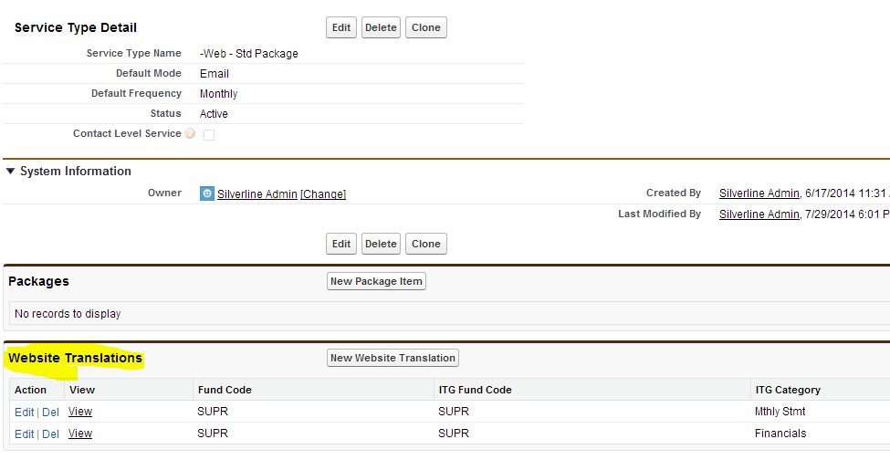

### XML Layout / Elements

Note: fields and sections that have been removed have been marked with Strikethrough Font:

* serviceexport
  + ~~Metadata~~
    - ~~Context~~
      * ~~Item~~
    - ~~Parameters~~
  + Data
    - Services
      * Service

### XML Attributes

Note: fields and sections that have been removed have been marked with Strikethrough Font:

|  |  |  |
| --- | --- | --- |
| **~~Context Item Name~~** | **~~Item Value~~** | **~~Example - Description~~** |
| ~~generatedBy~~ | ~~Text~~ | ~~MSSQL Stored Procedure~~ |
| ~~generatedBy2~~ | ~~Text~~ | ~~sp_web_exportcontactlevelservices~~ |
| ~~generatedByVersion~~ | ~~Number~~ | ~~1.3a~~ |
| ~~sequenceNumber~~ | ~~Number~~ | ~~00025006~~ |
| ~~serverMachine~~ | ~~Text~~ | ~~AGSQL-SQL\AGSQL~~ |
| ~~executeDateTime~~ | ~~Date/Time~~ | ~~2014-07-28T15:15:46.9476129Z~~ |
| ~~executeUser~~ | ~~Text~~ | ~~NYC\MGroves~~ |
| ~~executeHost~~ | ~~Text~~ | ~~MGROVES-VM01~~ |
| ~~localOutputFileName~~ | ~~Text~~ | ~~…~~ |
| ~~localOutputFilePath~~ | ~~Text~~ | ~~\\data1\Apps\ITG\TransferDEV\Out~~ |
| ~~localOutputFileSize~~ | ~~Number~~ | ~~86421~~ |

|  |  |  |
| --- | --- | --- |
| **~~Context Parameter Name~~** | **~~Parameter Value~~** | **~~Example - Description~~** |
| ~~writefile~~ | ~~Number~~ | ~~1~~ |
| ~~autocommit~~ | ~~Number~~ | ~~1~~ |
| ~~outputPath~~ | ~~Text~~ | ~~\\data1\Apps\ITG\TransferDEV\Out~~ |

|  |  |  |
| --- | --- | --- |
| **Services Attribute** | **Value** | **Example - Description** |
| ~~seq~~ | ~~text~~ | ~~Auto incremented number of Service Records~~ |
| id | Text | Contact_Service__c.ID |
| slxService | Text | Contact_Service__c.Service_Text__c |
| deliveryRule | Formula (Text) | Delivery_Rule__c |
| contactid | Text | Contact_Service__c. Contact__c |
| itgCategory | Text | Contact_Service > Service Type > Web Translation |
| ~~ruleID~~ | Text | ~~C_000001~~ |
| ~~csum~~ | ~~text~~ | ~~2066933031~~ |

### Open Questions:

* ~~How does the Service Method of Email, Fax, etc, translate to the deliveryRule of E,H, etc?~~

## Service Export

The Service Level Export file is an XML file that will contain all Fund, Organization, Investor Account, Contact, and Service Information for a particular Fund Family. The file will always be ran for 1 specific Fund Family at a time, which could mean any number of Funds

The XML file will be broken up by Metadata and Data elements, with the data elements containing Fund, Organization, Investor Account, Contact, and Service elements which will all derive from their corresponding Objects as follows:

|  |  |  |
| --- | --- | --- |
| **XML Data Element** | **Salesforce Object(s)** | **Description** |
| funds | Fund__c | Funds that all have a Group_Code__c that matches the value that the file is being generated for |
| orgs | Account Investor_Account__c Investment__c | All Organizations that Have Investments in the list of Funds Above |
| accounts | Investor_Account__c Investment__c | All Investor Accounts with Investments with the list of Funds Above |
| contacts | Contact Investor_Contacts__c Investor_Account__c | All Contacts that have an Investor Contact with an Investor Account from the list Above |
| services | Contact_Service__c  Service_Types__c  Fund__c  Website_Translation__c | All Contact Service Records for the List of Contact Above broken out by the Web Translation values for each Service Type – Fund pair |

The Same Web Translations Object that is described in the Contact Level Services section above is also used here as well.

### XML Layout / Elements

Note: fields and sections that have been removed have been marked with Strikethrough Font:

* serviceexport
  + Metadata
    - Context
      * Item
    - Parameters
  + Data
    - funds
    - orgs
    - accounts
    - contacts
    - services

### XML Attributes

Note: fields and sections that have been removed have been marked with Strikethrough Font:

|  |  |  |
| --- | --- | --- |
| **~~Context Item Name~~** | **~~Item Value~~** | **~~Example - Description~~** |
| ~~generatedBy~~ | ~~Text~~ | ~~MSSQL Stored Procedure~~ |
| ~~generatedBy2~~ | ~~Text~~ | ~~sp_web_exportservice~~ |
| ~~generatedByVersion~~ | ~~Number~~ | ~~1.5~~ |
| ~~sequenceNumber~~ | ~~Number~~ | ~~00025007~~ |
| ~~serverMachine~~ | ~~Text~~ | ~~AGSQL-SQL\AGSQL~~ |
| ~~executeDateTime~~ | ~~Date/Time~~ | ~~2014-07-28T15:15:46.9476129Z~~ |
| ~~executeUser~~ | ~~Text~~ | ~~NYC\MGroves~~ |
| ~~executeHost~~ | ~~Text~~ | ~~MGROVES-VM01~~ |
| ~~localOutputFileName~~ | ~~Text~~ | ~~00025007-sp_web_exportservice-20140728151551.xml~~ |
| ~~localOutputFilePath~~ | ~~Text~~ | ~~\\data1\Apps\ITG\TransferDEV\Out~~ |
| ~~localOutputFileSize~~ | ~~Number~~ | ~~86421~~ |

|  |  |  |
| --- | --- | --- |
| **~~Context Parameter Name~~** | **~~Parameter Value~~** | **~~Example - Description~~** |
| ~~writefile~~ | ~~Number~~ | ~~1~~ |
| ~~autocommit~~ | ~~Number~~ | ~~1~~ |
| ~~outputPath~~ | ~~Text~~ | ~~\\data1\Apps\ITG\TransferDEV\Out~~ |

|  |  |  |
| --- | --- | --- |
| **Funds Attribute:** | **Value** | **Source / Example** |
| ~~seq~~ | ~~Number~~ | ~~Auto incremented number of Funds~~ |
| code | Text | Fund__c.Fund_Code__c |
| id | Text | Fund__c.ID |
| ~~csum~~ | ~~number~~ | ~~593934508~~ |

|  |  |  |
| --- | --- | --- |
| **Orgs Attribute** | **Value** | **Example - Description** |
| ~~seq~~ | ~~Number~~ | ~~Auto incremented number of Orgs~~ |
| id | Text | Account.ID |
| name | Text | Account.Name |
| ~~csum~~ | ~~text~~ | ~~2066933031~~ |

|  |  |  |
| --- | --- | --- |
| **Accounts Attribute** | **Value** | **Example - Description** |
| ~~seq~~ | ~~Number~~ | ~~Auto incremented number of Inv Accts~~ |
| id | Text | Investor_Account__c.ID |
| code | Text | Investor_Account__c.Account_Code__c |
| name | Text | Investor_Account__c.Investor_Account_Name__c |
| status | Text | Investor_Account__c.Account_Status__c |
| orgid | Text | Investor_Account__c.Organization__c |
| ~~csum~~ | ~~text~~ | ~~2066933031~~ |

|  |  |  |
| --- | --- | --- |
| **Contacts Attribute** | **Value** | **Example - Description** |
| ~~Seq~~ | ~~Number~~ | ~~Auto incremented number of Contacts~~ |
| id="C6UJ9A001COK" | Text | Contact.ID |
| email="cabdi@fcrealtyad.com" | Text | Contact.Email |
| orgid="A6UJ9A000N3W" | Text | Contact.Account |
| lastName="Abdi" | Text | Contact.LastName |
| firstName="Charles" | Text | Contact.FirstName |
| prefix="Mr." | Text | Contact.Salutation |
| salutation="Charles" | Text | Contact. Preferred_Name__c |
| formattedSalutation | Formula (Text) | Contact.Formatted_Salutation__c |
| formattedAddress="Mr. Charles Abdi\r5145 Green Willow Lane\rSand Diego, CA 92130" | Formula (Text) | Contact.Formatted_Address__c |
| address1="5145 Green Willow Lane" | Text | Contact.OtherAddressStreet |
| city="Sand Diego" | Text | Contact.OtherAddressCity |
| state="CA" | Text | Contact.OtherAddressState |
| postalCode="92130" | Number | Contact.OtherAddressPostalCode |
| ~~csum~~ | ~~text~~ | ~~2066933031~~ |

|  |  |  |
| --- | --- | --- |
| **Services Attribute** | **Value** | **Example - Description** |
| ~~seq~~ | ~~Number~~ | ~~Auto incremented number of Translated Service Records~~ |
| id | Text | Contact_Service__c.ID |
| ~~iakey~~ | ~~Text~~ | Contact_Service__c. Fund_Code__c & “-”& Investor_Account__c.Account_Code__c |
| fundCode | Text | Contact_Service__c.Fund_Code__c |
| ~~accountCode~~ | ~~Text~~ | Investor_Account__c.Account_Code__c |
| slxService | Text | Contact_Service__c.Service_Text__c |
| deliveryRule | Formula (Text) | Delivery_Rule__c |
| contactid | Text | Contact_Service__c. Contact__c |
| accountid | Text | Contact_Service__c. Contact__c > AccountID |
| ~~csum~~ | ~~Text~~ | ~~2066933031~~ |
| itgFundCode | Text | Website_Translation__c.ITG_Fund_Code__c |
| itgCategory | Text | Website_Translation__c.ITG_Category__c |
| ~~ruleID~~ | ~~Text~~ | ~~C_000001~~ |

### Open Questions:

* ~~What is the delivery Rule mapping ( same question as above )? – answered above~~

## Valuation Export

The Valuations Export file is an XML file that will contain all

The XML file will be broken up by Metadata and Data elements, with the data elements containing

### XML Layout / Elements

Note: fields and sections that have been removed have been marked with Strikethrough Font:

* Val-export
  + Metadata
    - Context
      * Item
    - Parameters
  + Data
    - batches
      * batch
        + balances

### XML Attributes

Note: fields and sections that have been removed have been marked with Strikethrough Font:

|  |  |  |
| --- | --- | --- |
| **~~Context Item Name~~** | **~~Item Value~~** | **~~Example - Description~~** |
| ~~generatedBy~~ | ~~Text~~ | ~~MSSQL Stored Procedure~~ |
| ~~generatedBy2~~ | ~~Text~~ | ~~sp_web_exportvaluation~~ |
| ~~generatedByVersion~~ | ~~Number~~ | ~~1.3a~~ |
| ~~sequenceNumber~~ | ~~Number~~ | ~~00025006~~ |
| ~~serverMachine~~ | ~~Text~~ | ~~AGSQL-SQL\AGSQL~~ |
| ~~executeDateTime~~ | ~~Date/Time~~ | ~~2014-07-28T15:15:46.9476129Z~~ |
| ~~executeUser~~ | ~~Text~~ | ~~NYC\MGroves~~ |
| ~~executeHost~~ | ~~Text~~ | ~~MGROVES-VM01~~ |
| ~~localOutputFileName~~ | ~~Text~~ | ~~00025008-sp_web_exportvaluation-20140728151908.xml~~ |
| ~~localOutputFilePath~~ | ~~Text~~ | ~~\\data1\Apps\ITG\TransferDEV\Out~~ |
| ~~localOutputFileSize~~ | ~~Number~~ | ~~86421~~ |

|  |  |  |
| --- | --- | --- |
| **Context Parameter Name** | **Parameter Value** | **Example – Description** |
|  |  |  |
| funds | Text | SUPR |
| ~~writefile~~ | ~~Number~~ | ~~1~~ |
| ~~autocommit~~ | ~~Number~~ | ~~1~~ |
| gldate | Date | 2014-03-31 |
| ~~outputPath~~ | ~~Text~~ | ~~\\data1\Apps\ITG\TransferDEV\Out~~ |

|  |  |  |
| --- | --- | --- |
| **Balances Attribute** | **Value** | **Example – Description** |
| ~~seq~~ | ~~text~~ | ~~Auto incremented number of Service Records~~ |
| glDate | GL_Date__c | GL_Date__c |
| currency | Currency__c | Currency__c |
| priorNAV | Prior_NAV__c | Prior_NAV__c |
| nav | NAV__c | NAV__c |
| fundCode | Fund_Code__c | Fund_Code__c |
| accountCode | Account_Code__c | Account_Code__c |
| iaKey | IA_Key__c | IA_Key__c |
| investorName | Investor_Account__c | Investor_Account__c |
| mtd | MTD__c | MTD__c |
| qtd | QTD__c | QTD__c |
| ytd | YTD__c | YTD__c |
| irr | IRR__c | IRR__c |
| totalCommitment | Total_Committed__c | Total_Committed__c |
| totalCalled | Total_Called__c | Total_Called__c |
| totalDistributed | Total_Distributions__c | Total_Distributions__c |
| totalTransferred | Total_Transferred__c | Total_Transferred__c |

# Investran

Salesforce to 1 XML file export with Investor, Investor contacts, and Investor contact details. XML file will be generated using Custom Code using the same approach as documented in section 3 above.

## XML Layout / Elements

* serviceexport
  + Metadata
    - Context
      * Item
    - Parameters
  + Data
    - Investor
    - InvestorContact
      * Name
      * Email
      * Telephone
        + Type=Fax
        + Type=Business
      * Address
        + Type=Primary
      * Correspondence
        + Delivery
        + RecipientType
        + Type

### XML Attributes

|  |  |  |
| --- | --- | --- |
| **XML Data Element** | **Salesforce Object(s)** | **Description** |
| Investor | Investor_Account__c | Investor Accounts related to fund Ids passed to this page |
| InvestorContact | Investor_Contact__c | Contacts related to the above Investor Account |
| Correspondence | Contact_Service__c | Investor Services related to both the Investor and the Contact |

|  |  |  |
| --- | --- | --- |
| **Investor Attribute Key** | **Attribute Value** | **Source/ Example** |
| AGAccountNumber | Text | Investor_Account__c .Account_Code__c |
| InvestorID | Id | Investor_Account__c.Id |
| Name | Text | Investor_Account__c.Name |

|  |  |  |
| --- | --- | --- |
| **InvestorContact Key** | **Attribute Value** | **Source/ Example** |
| Name | Text | Investor_Contact__c.Contact_Name__c |
| FirstName | Text | Investor_Contact__c .contact.FirstName |
| LastName | Text | Investor_Contact__c.contact.LastName |
| MiddleName | Text | Investor_Contact__c.contact.Middle_Name__c |
| Prefix | Text | Investor_Contact__c.contact. Salutation |
| Suffix |  | Investor_Contact__c.contact.Suffix |
| SLXAccountID | Text | Investor_Contact__c.contact. SLX_Source__c |
| SLXContactID | Text | Investor_Contact__c.contact. SLX_Contact_ID__c |
| Organization | Text | Investor_Contact__c.Name |

|  |  |  |
| --- | --- | --- |
| **InvestorContact Child Key** | **Attribute Value** | **Source/ Example** |
| ContactEmail.Address where Type="Email" IsDefault="true" | Text | Investor_Contact__c.contact.email |
| ContactTelephone.phone where Type="Business" | Text | Investor_Contact__c.contact.phone |
| ContactTelephone. Number where Type="Fax" | Text | Investor_Contact__c.contact.fax |
| ContactAddress.STREET | Text | Investor_Contact__c.contact.OtherStreet |
| ContactAddress.City | Text | Investor_Contact__c.contact.OtherCity |
| ContactAddress.State | Text | Investor_Contact__c.contact.OtherState |
| ContactAddress. PostalCode | Text | Investor_Contact__c.contact. OtherPostalCode |
| ContactAddress.Country | Text | Investor_Contact__c.contact. OtherCountry |
| SLXAddressID | Text | Investor_Contact__c.contact. SLX_Primary_Address_ID__c |
| ContactUDF.Dear | Text | Investor_Contact__c.contact. Preferred_Name__c |

|  |  |  |
| --- | --- | --- |
| **Correspondence Key** | **Attribute Value** | **Source/ Example** |
| Type | Text | Contact_Service__c.Service.Name |
| Delivery | Text | Contact_Service__c.Service.Default_Mode__c |
| RecipientType | Text | ???? |